20 Oct
20 October

- Review draft - Add to draft
- Prepare ethics applications - AR will work from 6pm
- Add a survey - Google form within the Ethics folder - todo
- Review criteria for evaluation. - todo

n simple terms, explain the background and importance of this research
- Do not include citations, explain all abbreviations and avoid using complex technical terms.
- Refer to Readable's text scoring tool for tips to improve readability.
Engineering students and professionals are increasingly using AI to support technical and ethical decisions such as …
However, AI can hallucinate, show bias or be confidently wrong. Though AI increases productivity, can do this in a compelling way making it hard to distinguish good advice from bad under the pressure of time, risk, responsibility or complexity
If engineers (especially experienced) rely on that advise WITHOUT scrutinising independent ethical reasoning is undermine instead of reinforced.
Engineer often have SEVERAL AI systems advising them, which add further complexity (conflicting advice, more information, several points of info, or the tendency to go with “majority”)
How should ethic education track these multifaceted and overlapping problems?

List the aims or hypotheses of the research project
The aim of this research is to investigate whether the practice of making AI-agent disagreement visible (dissent visibility) as a governance mechanism reduces students' over-reliance on AI advice and improves ethical decision-making in a multi-agent AI ethics-training platform.

Give a brief overview of the research design

FYP_B example:
Women experience different health concerns from men because of their biological, social, and cultural experiences. These can include the demands of caring for others and motherhood. Women are also more likely to experience some long-term physical illnesses and mental health conditions. Many health survey tools often do not use adaptive questionnaires and do not fully consider women’s experiences and needs. By investigating an adaptive self-assessment platform, we can improve the quality of life and wellbeing of women.

=

Aim: This research aims to develop a human-centric self-assessments tool that focuses on women’s perspectives and different areas of their health, including personal and private health concerns.

Hypothesis: We believe that the developed tool will encourage women to pay more attention to their health and feel comfortable assessing their own health needs. The tool will also provide a secure, non-judgemental, respectful and supportive experience for women from diverse social and cultural backgrounds with different health needs.
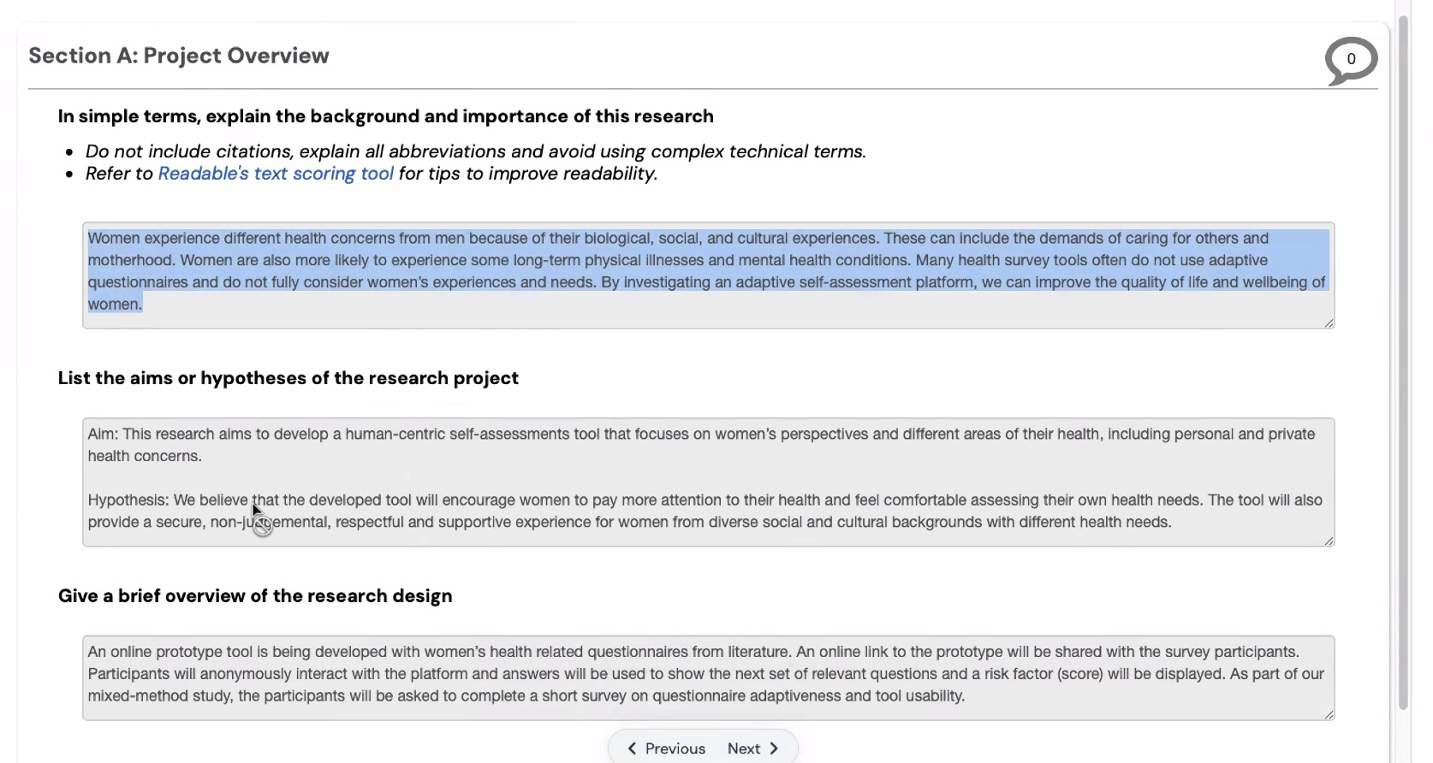
==

An online prototype tool is being developed with women’s health related questionnaires from literature. An online link to the prototype will be shared with the survey participants. Participants will anonymously interact with the platform and answers will be used to show the next set of relevant questions and a risk factor (score) will be displayed. As part of our mixed-method study, the participants will be asked to complete a short survey on questionnaire adaptiveness and tool usability.

Final ERM version:

Students and professionals are increasingly using AI to guide technical and ethical decisions. However, AI can hallucinate, show bias or be confidently wrong. While AI increases productivity, powerful generative and agentic AI tools provide compelling assistance that makes it hard to distinguish reliable advice from poor counsel when students and professionals face time pressure, risk, or complexity. Furthermore, conflicting advice from multiple AI agents adds further complexity and encourages conformity with the majority without scrutinising independent ethical reasoning. By investigating a multi-agent AI governance and ethics training platform, we can reduce over-reliance on AI advice and improve the quality of ethical decision making for both students and professionals.

Aim: This research aims to develop a multi-agent AI governance and ethics training tool that focuses on disagreement visible as a governance mechanism.

Hypothesis: We believe that the developed tool will help students and professionals reduce over-reliance on AI guidance and improve the quality of ethical decision making. The tool will also provide a secure, non-judgemental environment for on-going ethics training.

An online prototype tool is being developed with LLM-enhanced complex ethical scenarios from literature. An online link to the prototype will be shared with the survey participants. Participants will anonymously interact with the platform, read complex ethical scenarios to make independent decisions with or without disagreement visible from AI agents and a decision quality score will be displayed. As part of our mixed-method study, the participants will be asked to complete a short survey on the over-reliance on AI guidance and quality of ethical decision making.

13 Oct
13 Octodo

- Review draft - Add to draft
- Prepare ethics applications - AR will work from 6pm
- Add a survey - Google form within the Ethics folder - todo
- Review criteria for evaluation. - todo

6 Oct 2026 | FIT4701/2 Meeting - Agentic AI Platf…

6 Oct 2026 | FIT4701/2 Meeting - Agentic AI Platform
Attendees: ABM Russel Aryan Cyrus Ubaid Irfan

CLEANED/updated google form questions ( paper draft):
Demographic question/?
- Age range (e.g., 18–24)
- Current status: engineering student / early-career engineer (<5 yrs) / experienced engineer/ other
- Engineering discipline?
- Ethnicity?
- How often do you use AI tools (ChatGPT, Copilot, etc.) in your work or study? (Never / Rarely / Monthly / Weekly / Daily)

REFLECTION QUESTIONS
- What could make the AI agent more trustworthy?
- Was visible dissent helpful in how you make decisions? Why / why not?
- What would help you to make an effective decision?
- Did anything about the AI advice make you more or less willing to rely on it? (open text)

QUALITY REFLECTION: We could use the feedback
- How relevant did the 2 x scenarios feel compared to actual or perceived situations you've encountered or expect to encounter? (Likert 1–5) - Ambiguity/transparency, biased, cultural complexity…
- WasWere the scenarios and the AI advice (with dissent visible) easy to understand? (Likert 1–5) Clarity of AI advice, Completeness, Comprehensiveness,…
- Any suggestions for improving the scenarios, advice, or flow? (open text, optional)

MISC QUESTIONS:
- Workflow (dissent visible)
- Did summary at the end help? -

GOOGLE FORM ASK RUSSEL AND UBAID:
Demographic question/?
- Age range (e.g., 18–24)
- Current status: engineering student / early-career engineer (<5 yrs) / experienced engineer / other
- Engineering discipline?
- Ethnicity?
- How often do you use AI tools (ChatGPT, Copilot, etc.) in your work or study? (Never / Rarely / Monthly / Weekly / Daily)

REFLECTION QUESTIONS
- What could make the AI agent more trustworthy?

- What, if anything, made you keep or change your decision after seeing the AI's advice? (open text)
- Did AI influence/ help you to change your decisions
- if yes/no why etc
- Was visible dissent helpful in how you make decisions? Why / why not?
- What would help you to make an effective decision?

- Did anything about the AI advice make you more or less willing to rely on it? (open text)

QUALITY REFLECTION: We could use the feedback
- How relevant did the 2 x scenarios feel compared to actual or perceived situations you've encountered? (Likert 1–5) - Ambiguity/transparency, biased, cultural complexity…
- Was the AI advice (with dissent visible) easy to understand? (Likert 1–5) Clarity of AI advice, Completeness, Comprehensiveness,…
- Any suggestions for improving the scenarios, advice, or flow? (open text, optional)

MISC QUESTIONS:
- Workflow (dissent visible)
- Did summary at the end help?
- Do you have any concerns about how this study was conducted? (open text, optional)
- Would you like to receive a summary of the findings? (yes/no + optional email?) MAY NEED TO UPDATE MUHREC DOCS FOR THIS TO BE POSSIBLE?

Prototype changes (aryan):
- Condition is assigned, not chosen. assignCondition() in App.vue randomly assigns visible/hidden per session (could make this non random, we can split participants evenly). The old self-selected "View perspectives / skip" mecanic is gone.
- RO1 now has data to compute. Confidential Design Disclosure's AI consensus deliberately recommends the wrong option (D), while the stakeholder agent still correctly dissents towardt.
- RO3 has scenarios to split on: consensusLevel is tagged contested / high-consensus respectively.
- RO4 has a data source: new TrustScreen.vue + full Jian et al.12-item scale withcorrect FULL scale taken from Jian et al.
- Each trial now logs adviceCorrect, overRelied, consensusLevel, and dissentShown directly, so the exported session JSON is ready for RO1–RO4 analysis

RO IDEAS (how to measure each):

RO1: Measure the effect of dissent visibility on decision makers' behavioural over-reliance on incorrect AI advice.

RO1: Does seeing AI disagreement change how often people blindly follow bad advice?
When the AI's advice is wrong, how often does the participant's final answer match that wrong advice? IMPORTANT: We COUNT THIS SEPARATELY for the group that saw agents disagreeing and the group that didn't, then compare the two percentages. A lower percentage in the "disagreement visible" group means people were less likely to blindly copy bad advice.

RO2: Evaluate whether dissent visibility improves the accuracy of decision makers' final ethical decisions relative to expert-validated ground truth

RO2: Does it also make the final decision more accurate?
For scenarios with a clear right answer (experts agree), check what fraction of participants got it right. For scenarios without a single right answer (experts disagree among themselves), we check what fraction of participants landed within the range experts consider reasonable. We then cmompare these fractions between the two groups. (Ask russel, WHAT DOES BETTER MEan???)

RO3: Examine whether the effect of dissent visibility differs between high-consensus and ambiguous/contested ethical scenarios.

RO3: Does the effect depend on how tricky the scenario is?
Same two measurements as RO1/RO2, but split by scenario difficulty: "easy" scenarios where experts agree, versus "hard" ones where experts disagree. You check whether seeinthe hard scenarios than the easy ones. If 80% of expert agree, we count it as HIGH CONSENSUS.

RO4: Investigate whether dissent visibility affects decision makers' self-reported trust in the AI's advice, and whether that trust aligns with their actual behavioural reliance.

RO4: Do people's stated trust and their actual behaviour match up?
After each decision, ask participants a short standard survey about how much they trust the AI. Does saying you trust AI match your behaviour
WE know how much people copy AI answers in their session so we can compare their SELF REPORTED ANSWER with ACTUAL DATA

Notes
- Background - Intro + Lit survey + methodology draft is ready - AR will review.
- Get started with Ethics and run before or during FYP-B. - Need a prototype ready (static role) - live link in the survey ..
  - Docs 80% Done, to be reviewed by Russel
- Access to overleaf - done
- Introduction - Background/Lit review - Methodology - Preliminary results - Future work in S2.ongoing
- RRQs. Added to the daft pending AR review
- Methodology - Calculation ??? source (why this eq should remain same in our project) - ongoing
- Preliminary results - Personas - done, FR & NFRs - done, Mockups - done, survey design - todo, data matched with RQs - ongoing, identified all constraints - ongoing, benchmarks (own + literature) -onging - backed by stats…
- Week 9 - Introduction + Background/Lit review (including RQs) + WORK ON PROTOTYPE FIRST DRAFT DONE - AR to review
- Week 10 - Methodology + Preliminary result
- Week 11- Final draft
- Week 12 - Submit
- Make Ai agents dynamic - Static [need to control the outcome + constraints/guardrails]: ongoing - review by expert human (periodically updated responses for same participants)
- Need a working prototype for Ethics (req gathering + evaluation) FIRST DRAFT DONE
- Create a workflow diagram - user journey flow chart. Part of the methodology section.
- Prototype is separate from survey questions (qualitative and quantitative)
- Log the actions -> Logging: I implemented BARE MINIMUM VERSION in prototype: JSON LOGGING

Prototype:
- Local
- Scenario 1 of 4 :
  - Should be participants’ own selection
  - 4 scenarios
  - Add chart
  - Initial decision without help of Agentic AI
  - Final decision with help of Agentic AI roles
  - Add title scenario 1: The confidential design disclosure
  - Dissent visible - 2 + 2
Study design:
- How do you know the selected 4 scenarios are relevant to participants - x10 relevant - common among eng discipline or discipline specific [AI generated highly ambiguous - details of prompts - Engineering] and SE only then evaluated by human shortlist 2 for the prototype.
  - 1st: profitable vs community
  - 2nd:
  - 3rd:
  - 4th:
- Own - without DV - with DV (choice by participant) - Final [limit to two scenarios] - 1st
- Own - without DV - with DV (based on 1st scenario selection) - Final [limit to two scenarios] 2nd
- 4 scenarios [Highly ambiguous only] ->
- With DV + Without DV
- Start with 2 without DV x 2
- 2 with DV x 2
  - Progressive disclosure, deliver feedback scenario by scenario

Sept 18th - presentation feedback
- RQ is asking in a leading way; make it more general (“Affect” instead of “improve” etc)
- How will AI responses be standardized to avoid the SAME agent giving different answers every time?
  - Ideas:
    - Guardrails (.MD)
    - Static (This is not as good because it is very similar to existing methods )
- Mockup - it is not immediately clear the user is getting AI advice; the (even psychologically and subconsciously) may alter user behaviour.

24 Sept 2026 | FIT4701/2 Meeting - Agenti…

24 Sept 2026 | FIT4701/2 Meeting - Agentic AI Platform
Attendees: ABM Russel Aryan Cyrus Ubaid Irfan

Notes
- Background
- Get started with Ethics and run before or during FYP-B.
  - Docs 80% Done, to be reviewed by Russel
- Access to overleaf
- Introduction - Background/Lit review - Methodology - Preliminary results - Future work in S2.
- RRQs
- Methodology - Calculation ??? source (why this eq should remain same in our project)
- Preliminary results - Personas, FR & NFRs, Mockups, survey design, data matched with RQs, identified all constraints, benchmarks (own + literature) - backed by stats…
- Week 9 - Introduction + Background/Lit review (including RQs) + WORK ON PROTOTYPE FIRST DRAFT DONE
- Week 10 - Methodology + Preliminary result
- Week 11- Final draft
- Week 12 - Submit
- Make Ai agents dynamic - Static [need to control the outcome + constraints/guardrails]:
- Need a working prototype for Ethics (req gathering + evaluation) FIRST DRAFT DONE
- Prototype is separate from survey questions (qualitative and quantitative)
- Log the actions -> Logging: I implemented BARE MINIMUM VERSION in prototype: JSON LOGGING

Sept 18th - presentation feedback
- RQ is asking in a leading way; make it more general (“Affect” instead of “improve” etc)
- How will AI responses be standardized to avoid the SAME agent giving different answers every time?
  - Ideas:
    - Guardrails (.MD)
    - Static (This is not as good because it is very similar to existing methods )
- Mockup - it is not immediately clear the user is getting AI advice; the (even psychologically and subconsciously) may alter user behaviour.

15 Sept 2026 | FIT4701/2 Meeting - Agentic AI Pla…

15 Sept 2026 | FIT4701/2 Meeting - Agentic AI Platform
Attendees: ABM Russel Aryan Cyrus Ubaid Irfan

Sept 18th - presentation feedback
- RQ is asking in a leading way; make it more general (“Affect” instead of “improve” etc)
- How will AI responses be standardized to avoid the SAME agent giving different answers every time?
  - Ideas:
    - Guardrails (.MD)
    - Static (This is not as good because it is very similar to existing methods )
- Mockup - it is not immediately clear the user is getting AI advice; the (even psychologically and subconsciously) may alter user behaviour.

8 Sept 2026 | FIT4701/2 Meeting

8 Sept 2026 | FIT4701/2 Meeting - Agentic AI Platform
Attendees: ABM Russel Aryan Cyrus

- Setup Git repository
- Select tech stack
Frontend: Vue+tailwind frontend (Typescript)
Backend: Express.js
Containerised using Docker
Firebase for any authentication, Database and deployment
Github for git management
Claude sonnet 5 for AI model

- Update the poster (exclude marketing items)
- Develop formula to calculate score
Honestly, maybe this is a bad idea. The scoring of agents DEPENDS ON SITUATION/Senario. Some scenarios TIME is most important, some scenarios LEGAL consideration is most important.

MY SOLUTION 1: Weighted scoring system CUSTOMISED for each scenario.
Example:
- Agent 1: 1 vote
- Agent 2: 2 votes
- Agent 3: 0.5 votes
etc
Weighting ranked by EXPERTS
WE DO NOT SHOW WEIGHTING TO USERS

- Draft ppt - 10 mins (Introduction + Background + Lit reviews + Aim + RQs + methodology + preliminary results (mockups, personas and demo of stack + week by week timeline till May 2027/ Gantt chart))
- Contact interview panel to confirm presentation time [URGENT 4pm Friday 18th]
- Populate slides
- Ethics application status? [Aryan: Filled some sections out, only document uploads to go]
- Overleaf access?

"Investigate whether adding governance mechanisms to a multi-agent AI ethics-training platform reduce students' over-reliance on the AI and improve their ethical decision-making”

Central RQ: Do we need governance mechanisms to a multi-agent AI ethics-training platform?
- Convert issues into RQs backed by lit survey
- Unique roles to each agent
- Poor decision making
- Should we use utilitarian approach to agree with agent’s decision
- How to validate the final decision?
- What are the different roles required in a multi-agent AI ethics-training platform?

- R Objective 1: Investigate the consequences of a multi-agent AI ethics-training platform
  - RQ1.1: Can we rely on a multi-agent AI ethics-training platform?
    - Measure: Trust metrics based on accuracy and/or reputation - CRAP approach - find similar for measuring AI agent reliability…
    - RQ1.1a: Can flexibility in choosing own agents or fixed set of agents impact on ethical decision making?
      - Measure: System requirement - Fixed set of Agents vs Flexible Agents. Orchestration - sequentially (rule-based pre-determined) or other - compare different architecture
      - Does restricting users from choosing their own AI agents influence their ethical reasoning, potentially causing users to converge toward similar decisions?

RQ1.2: Does incorporating governance mechanisms in a multi-agent AI ethics-training platform improve ethical decision making?
    - Measure: System requirement - with or without
    - 1.2a: Is the effect of [Gov mechanism] on over-reliance and accuracy stronger for contested/ambiguous ethical cases than for cases with high expert consensus Refer to RQ1.2a
      - Remember the study from last week? Where they tested ONLY ON LOW RISK DECISION? We can fill that gap!
    - 1.2b: Do governance mechanisms increase the quality of overall ethical decision? Refer to RQ1.2b
      - RQ1.2b.1: Define quality of ethical decision - Accuracy???
        - Measure: If accuracy then % of correct answers
      - [BUILDS ON ABOVE]: Does [chosen gov mechanism] improve the accuracy of students' final ethical decisions relative to expert-validated ground truth?
Measure: % of final decisions matching the expert-consensus answer

    - 1.2c: Do governance mechanisms increase the reliability (using utilitarian or similar) of overall ethical decision? Refer to RQ1.2c
      - RQ1.2c.1: Define reliability of ethical decision - based on consensus/consequences/risk?
        - Measure:

    - RQ1.2d: Does showing dissent among a pool of AI agents reduce students' over-reliance on incorrect AI advice, compared to a no-dissent-visibility condition? Measure: Behavioural over-reliance ratio discussed in prev meetings

    - 1.2e: Does [Gov mechanism] reduce students' self-reported trust in the AI's advice, and does that align with their behavioural over-reliance?
  - Does trust == reliance?
  - Measure: Jian Et Al has a scale: (PDF) Foundations for an Empirically Determined Scale of Trust in Automated Systems
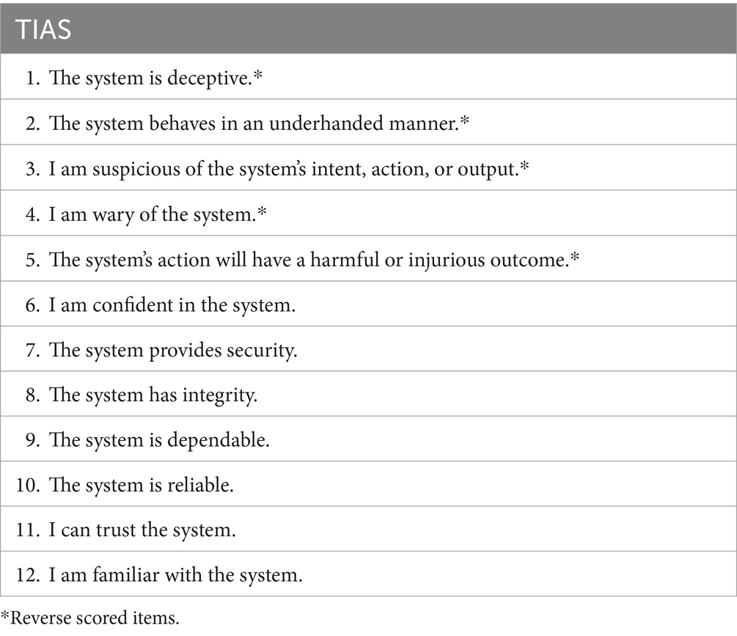

Reliability = accuracy against expert validated ans.

Action:
- Draft the Week 8 slide deck - 10 mins check the rubric.
- Inro+Related work -> gaps, RQs, Prelim work (design of the system Personas/FR/NFR/Mockups), Research design outline includes study design (quantitative/qualitative) using survey, Gantt chart/Week by week milestones plan for S2 delivery
- Overleaf template - IEEE format ()- Russel
- Initiate the MUHREC application?? Russel

In simple terms, explain the background and importance of this research
- Do not include citations, explain all abbreviations and avoid using complex technical terms.
- Refer to Readable's text scoring tool for tips to improve readability.

List the aims or hypotheses of the research project

Give a brief overview of the research design

NFR and FRS:
Some general ideas, it is very hard to know without know what the RQ actually is
FR:
Pre-:
- Selection of AI agents (Flexible choose your own agents from an existing agents skills vs pre-determined Fixed agents)
During:
- Multi-agent advice generation
  - distinct/specialised agent roles
- condition assignment
- ground-truth case bank
- incorrect-advice injection
- Agent consensus/disagreement control (whether/how agents disagree)
  - dissent surfacing/suppression (whether participant sees that disagreement)
Post-:
- decision capture; records initial/final decision AND reasoning
  - ethical/moral reasoning assessment (evaluates the recorded reasoning)
- revision/time logging
- Auto-scoring
- trust survey
- data export
- consent/withdrawal
- Scenario consensus/ambiguity classification (from RO4)
  - System needs some way to distinguish between:
    - High-consensus scenario (high expert consensus on ethically preferred decision)
    - ambiguous/contested scenario (potential disagreement about preferred decision)
NFR:
- Data integrity
- Latency
- privacy/anonymization
- Reliability
- Reproducibility
  - auditability/traceability: we need to reconstruct which scenario/condition/agent outputs led to each participant response.
- usability parity
- Security
- Maintainability
- Experimental consistency (ensuring experimental conditions differ only in intended manipulation)
- AI response consistency/controllability (our experiment needs control over AI outputs so the intended experimental condition actually occurs)
- Accessibility
Preliminary Mockup:
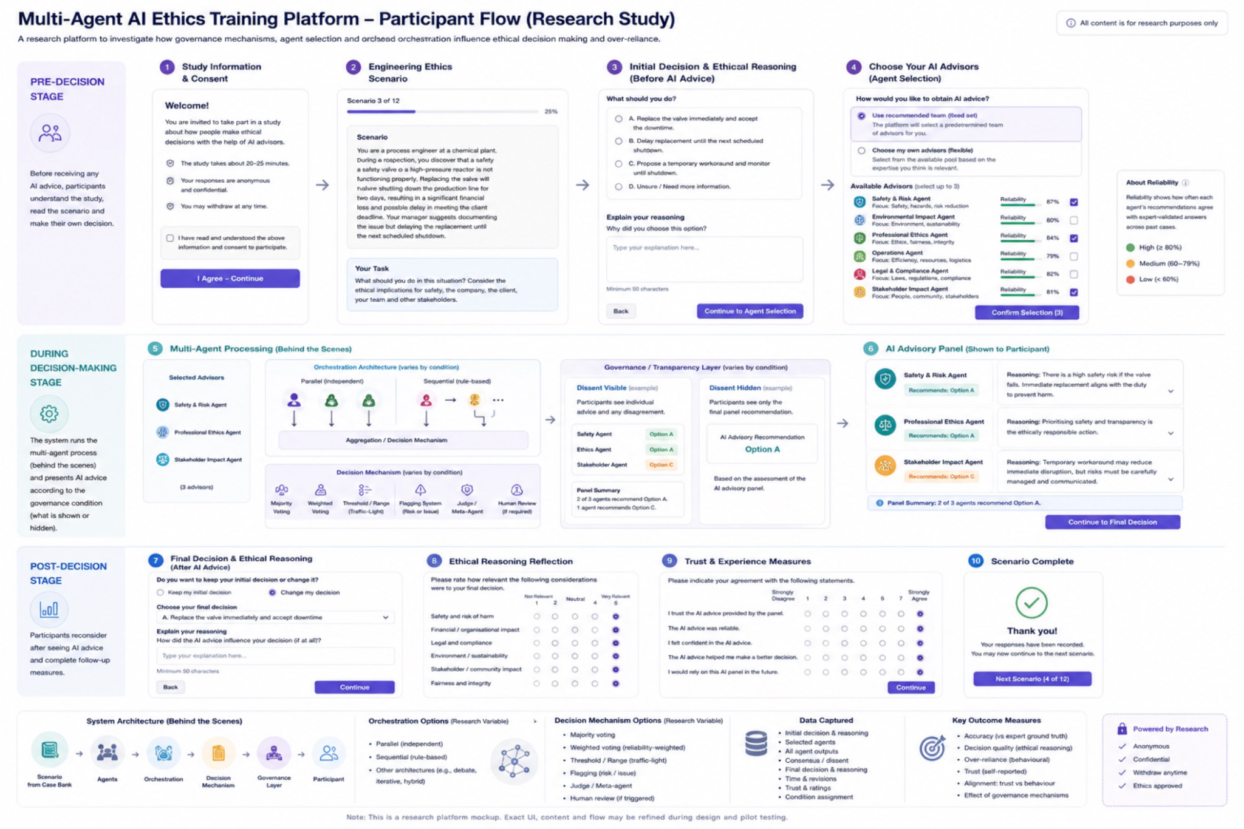
Flow: engineering ethics scenario → participant makes a decision → multi agent AI provides advice → participant can reconsider → final decision → collect measures

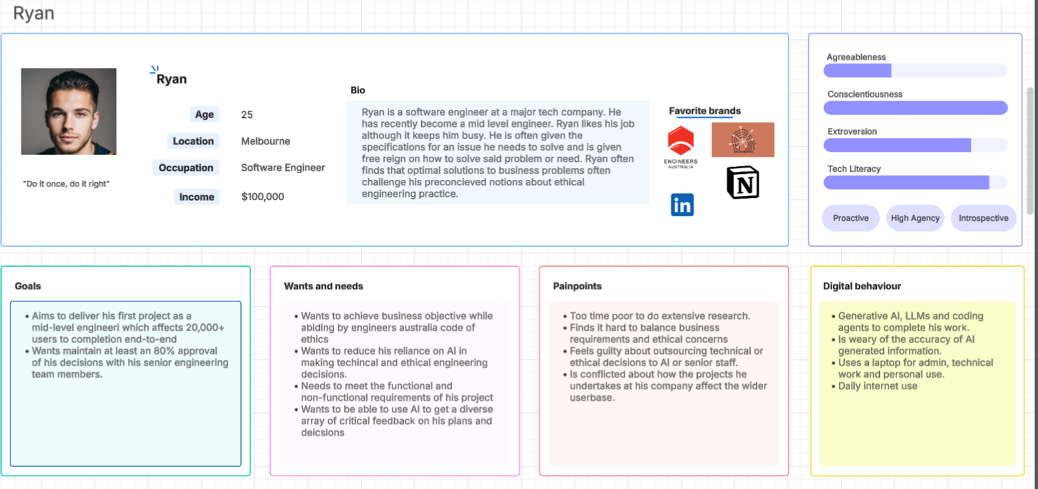
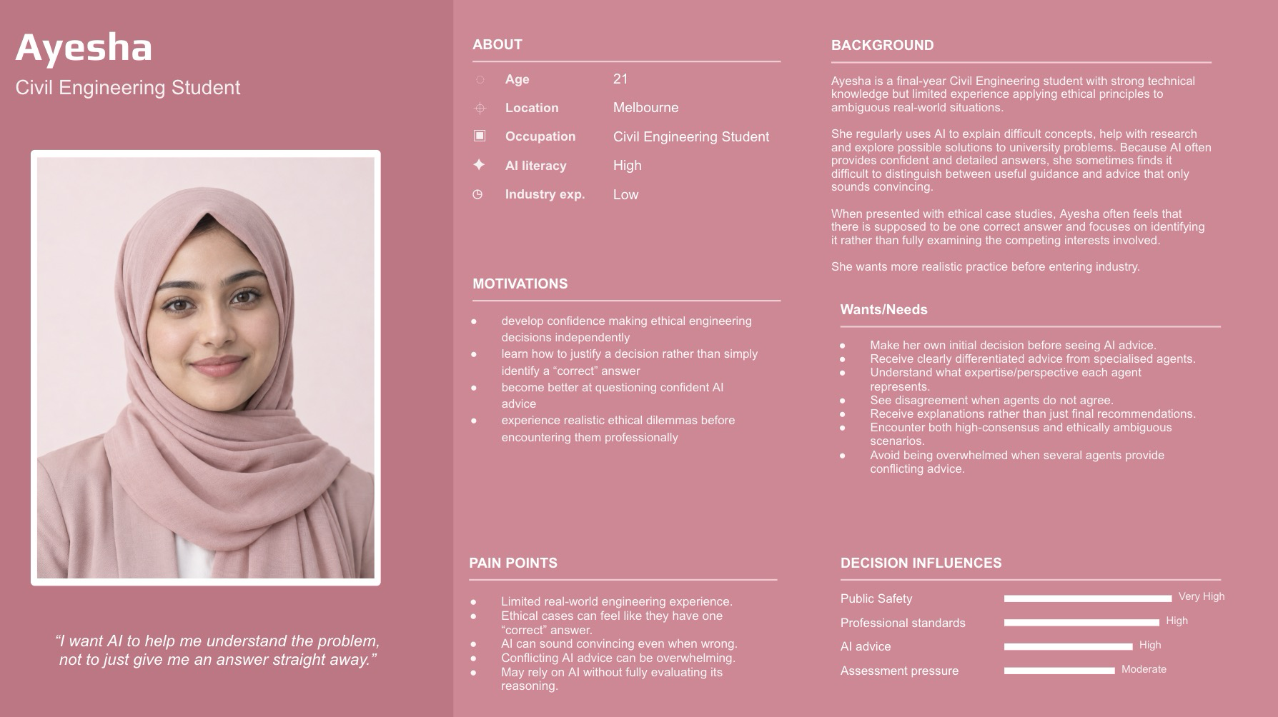
Ethics application : Design and Development of a multi-agent AI ethics-training platform.

Consider including in the background/lit survey/related work section.

- Over reliance definition - IfMath behind the calculation - need to know variables…. recursion what is your goal - <10% considering constraints
- Over-reliance = (number of cases where the student's final decision matches the AI's incorrect advice) ÷ (total number of cases where the AI's advice was incorrect)

Action items
- Lit surveys: Create an excel spreadsheet
- Start the template for W12 initial paper - 4 pages - Russel
- Ethics approval MUHREC - Russel
- Work on objectives - add more )
  - Added 1.2, 2.1.1, 4.0 and 5.0
- Identify requirements (FR and NFR) for our multi-agent AI ethics-training platform. (fixed set of Agents or flexible options)
- Mockups + Personas
- Prepare for the Week 8 interview presentation (Context, background, Aim, RQs, RM overview, prelim findings, PoC.., plan for S2 research - Gantt chart)
- CRAP: find similar for measuring AI agent reliability…
- Draft answer for three Ethics application questions?
- Log into the following: https://ethicsapps.monash.edu/ActivityForm/Index
- Module - Risk, OH&S Frevvo, ?? Sarah -> Week 5 - Russel to recheck the list.

In simple terms, explain the background and importance of this research
Do not include citations, explain all abbreviations and avoid using complex technical terms.
Refer to Readable's text scoring tool for tips to improve readability.

List the aims or hypotheses of the research pro

Give a brief overview of the research design
- Students - 18+ (exclude Malaysia and Indonesia citizens)
- Junior Working professional 18+ (<2 years of experience) - What types of decision - Technical and tactical
- IF Senior Working professional 18+ (5+ years of experience) - What types of decision - Business and strategic

1 Sept 2026 | FIT4701/2 Meeting

1 Sept 2026 | FIT4701/2 Meeting - Agentic AI Platform
Attendees: ABM Russel Aryan Cyrus Ubaid Irfan

"Investigate whether adding governance mechanisms to a multi-agent AI ethics-training platform reduce students' over-reliance on the AI and improve their ethical decision-making”

Central RQ: [to refine] Do we need governance mechanisms to a multi-agent AI ethics-training platform?
- Convert issues into RQs backed by lit survey
- Unique roles to each agent
- Poor decision making
- Should we use utilitarian approach to agree with agent’s decision
- How to validate the final decision?
- What are the different roles required in a multi-agent AI ethics-training platform?

FR: Stages?? Pre-, during, post-

- R Objective 1: Investigate the consequences of a multi-agent AI ethics-training platform
  - RQ1.1: Can we rely on a multi-agent AI ethics-training platform?
    - Measure: Trust metrics based on accuracy and/or reputation - CRAP approach - find similar for measuring AI agent reliability…
    - RQ1.1a: Can flexibility in choosing own agents or fixed set of agents impact on ethical decision making?
      - Measure: System requirement - Fixed set of Agents vs Flexible Agents. Orchestration - sequentially (rule-based pre-determined) or other - compare different architecture
      - Does restricting users from choosing their own AI agents influence their ethical reasoning, potentially causing users to converge toward similar decisions?

RQ1.2: Does incorporating governance mechanisms in a multi-agent AI ethics-training platform improve ethical decision making?
    - Measure: System requirement - with or without
    - 1.2a: Is the effect of [Gov mechanism] on over-reliance and accuracy stronger for contested/ambiguous ethical cases than for cases with high expert consensus Refer to RQ1.2a
      - Remember the study from last week? Where they tested ONLY ON LOW RISK DECISION? We can fill that gap!
    - 1.2b: Do governance mechanisms increase the quality of overall ethical decision? Refer to RQ1.2b
      - RQ1.2b.1: Define quality of ethical decision - Accuracy???
        - Measure: If accuracy then % of correct answers
      - [BUILDS ON ABOVE]: Does [chosen gov mechanism] improve the accuracy of students' final ethical decisions relative to expert-validated ground truth?
Measure: % of final decisions matching the expert-consensus answer

    - 1.2c: Do governance mechanisms increase the reliability (using utilitarian or similar) of overall ethical decision? Refer to RQ1.2c
      - RQ3.1: Define reliability of ethical decision - based on consensus/consequences/risk?
        - Measure:

    - RQ1.2d: Does showing dissent among a pool of AI agents reduce students' over-reliance on incorrect AI advice, compared to a no-dissent-visibility condition? Measure: Behavioural over-reliance ratio discussed in prev meetings

    - 1.2e: Does [Gov mechanism] reduce students' self-reported trust in the AI's advice, and does that align with their behavioural over-reliance?
  - Does trust == reliance?
  - Measure: Jian Et Al has a scale: (PDF) Foundations for an Empirically Determined Scale of Trust in Automated Systems

Reliability = accuracy against expert validated ans.

Action:
- Draft the Week 8 slide deck - 10 mins check the rubric.
- Inro+Related work -> gaps, RQs, Prelim work (design of the system Personas/FR/NFR/Mockups), Research design outline includes study design (quantitative/qualitative) using survey, Gantt chart/Week by week milestones plan for S2 delivery
- Overleaf template - IEEE format ()- Russel
- Initiate the MUHREC application?? Russel

In simple terms, explain the background and importance of this research
- Do not include citations, explain all abbreviations and avoid using complex technical terms.
- Refer to Readable's text scoring tool for tips to improve readability.

List the aims or hypotheses of the research project

Give a brief overview of the research design

NFR and FRS:
Some general ideas, it is very hard to know without know what the RQ actually is
FR:
Pre-:
- Selection of AI agents (Flexible choose your own agents from an existing agents skills vs pre-determined Fixed agents)
During:
- Multi-agent advice generation
  - distinct/specialised agent roles
- condition assignment
- ground-truth case bank
- incorrect-advice injection
- Agent consensus/disagreement control (whether/how agents disagree)
  - dissent surfacing/suppression (whether participant sees that disagreement)
Post-:
- decision capture; records initial/final decision AND reasoning
  - ethical/moral reasoning assessment (evaluates the recorded reasoning)
- revision/time logging
- Auto-scoring
- trust survey
- data export
- consent/withdrawal
- Scenario consensus/ambiguity classification (from RO4)
  - System needs some way to distinguish between:
    - High-consensus scenario (high expert consensus on ethically preferred decision)
    - ambiguous/contested scenario (potential disagreement about preferred decision)
NFR:
- Data integrity
- Latency
- privacy/anonymization
- Reliability
- Reproducibility
  - auditability/traceability: we need to reconstruct which scenario/condition/agent outputs led to each participant response.
- usability parity
- Security
- Maintainability
- Experimental consistency (ensuring experimental conditions differ only in intended manipulation)
- AI response consistency/controllability (our experiment needs control over AI outputs so the intended experimental condition actually occurs)
- Accessibility
Preliminary Mockup:
Flow: engineering ethics scenario → participant makes a decision → multi agent AI provides advice → participant can reconsider → final decision → collect measures

Ethics application : Design and Development of a multi-agent AI ethics-training platform.

Consider including in the background/lit survey/related work section.

- Over reliance definition - IfMath behind the calculation - need to know variables…. recursion what is your goal - <10% considering constraints
- Over-reliance = (number of cases where the student's final decision matches the AI's incorrect advice) ÷ (total number of cases where the AI's advice was incorrect)

Action items
- Lit surveys: Create an excel spreadsheet
- Start the template for W12 initial paper - 4 pages - Russel
- Ethics approval MUHREC - Russel
- Work on objectives - add more )
  - Added 1.2, 2.1.1, 4.0 and 5.0
- Identify requirements (FR and NFR) for our multi-agent AI ethics-training platform. (fixed set of Agents or flexible options)
- Mockups + Personas
- Prepare for the Week 8 interview presentation (Context, background, Aim, RQs, RM overview, prelim findings, PoC.., plan for S2 research - Gantt chart)
- CRAP: find similar for measuring AI agent reliability…
- Draft answer for three Ethics application questions?
- Log into the following: https://ethicsapps.monash.edu/ActivityForm/Index
- Module - Risk, OH&S Frevvo, ?? Sarah -> Week 5 - Russel to recheck the list.

In simple terms, explain the background and importance of this research
Do not include citations, explain all abbreviations and avoid using complex technical terms.
Refer to Readable's text scoring tool for tips to improve readability.

List the aims or hypotheses of the research pro

Give a brief overview of the research design
- Students - 18+ (exclude Malaysia and Indonesia citizens)
- Junior Working professional 18+ (<2 years of experience) - What types of decision - Technical and tactical
- IF Senior Working professional 18+ (5+ years of experience) - What types of decision - Business and strategic

25 Aug 2026 | FIT4002 Seminar

25 Aug 2026 | FIT4002 Seminar
Attendees: Ubaid, Aryan, Russel

Notes
- Aim:

"Investigate whether adding governance mechanisms to a multi-agent AI ethics-training platform reduce students' over-reliance on the AI and improve their ethical decision-making”

Central RQ: [to refine] Do we need governance mechanisms to a multi-agent AI ethics-training platform?
- Convert issues into RQs backed by lot survey
- Unique roles to each agent
- Poor decision making
- Should we use utilitarian approach to agree with agent’s decision
- How to validate the final decision?
- What are the different roles required in a multi-agent AI ethics-training platform?

FR: Stages?? Pre-, during, post-

- R Objective 1: Investigate the consequences of a multi-agent AI ethics-training platform
  - RQ1.1: Can we rely on a multi-agent AI ethics-training platform?
    - Measure: Trust metrics based on accuracy and/or reputation - CRAP approach - find similar for measuring AI agent reliability…

RQ1.2: Does incorporating governance mechanisms in a multi-agent AI ethics-training platform improve ethical decision making?
    - Measure: System requirement - with or without

  - RQ1.3: Can flexibility in choosing own agents or fixed set of agents impact on ethical decision making?
    - Measure: System requirement - Fixed set of Agents vs Flexible Agents. Orchestration - sequentially (rule-based pre-determined) or other - compare different architecture
    - Does restricting users from choosing their own AI agents influence their ethical reasoning, potentially causing users to converge toward similar decisions?

  - RQ1.44: Does showing dissent among a pool of AI agents reduce students' over-reliance on incorrect AI advice, compared to a no-dissent-visibility condition? Measure: Behavioural over-reliance ratio discussed in prev meetings
- R Objective 2: Do governance mechanisms increase the quality of overall ethical decision? Refer to RQ1.2b
  - RQ2.1: Define quality of ethical decision - Accuracy???
    - Measure: If accuracy then % of correct answers
  - RQ2.1.1 [BUILDS ON ABOVE]: Does [chosen gov mechanism] improve the accuracy of students' final ethical decisions relative to expert-validated ground truth?
Measure: % of final decisions matching the expert-consensus answer

- R Objective 3: Do governance mechanisms increase the reliability (using utilitarian or similar) of overall ethical decision? Refer to RQ1.2c
  - RQ3.1: Define reliability of ethical decision - based on consensus/consequences/risk?
    - Measure:
- R Objective 4: Is the effect of [Gov mechanism] on over-reliance and accuracy stronger for contested/ambiguous ethical cases than for cases with high expert consensus Refer to RQ1.2a
  - Remember the study from last week? Where they tested ONLY ON LOW RISK DECISION? We can fill that gap!
- R Objective 5: Does [Gov mechanism] reduce students' self-reported trust in the AI's advice, and does that align with their behavioural over-reliance?
  - Does trust == reliance?
  - Measure: Jian Et Al has a scale: (PDF) Foundations for an Empirically Determined Scale of Trust in Automated Systems

Reliability = accuracy against expert validated ans.

NFR and FRS:
Some general ideas, it is very hard to know without know what the RQ actually is
FR:
Pre-:
- Selection of AI agents (Flexible choose your own agents from an existing agents skills vs pre-determined Fixed agents)
During:
- Multi-agent advice generation
  - distinct/specialised agent roles
- condition assignment
- ground-truth case bank
- incorrect-advice injection
- Agent consensus/disagreement control (whether/how agents disagree)
  - dissent surfacing/suppression (whether participant sees that disagreement)
Post-:
- decision capture; records initial/final decision AND reasoning
  - ethical/moral reasoning assessment (evaluates the recorded reasoning)
- revision/time logging
- Auto-scoring
- trust survey
- data export
- consent/withdrawal
- Scenario consensus/ambiguity classification (from RO4)
  - System needs some way to distinguish between:
    - High-consensus scenario (high expert consensus on ethically preferred decision)
    - ambigious/contested scenario (potential disagreement about preferred decision)
NFR:
- Data integrity
- Latency
- privacy/anonymization
- Reliability
- Reproducibility
  - auditability/traceability: we need to reconstruct which scenario/condition/agent outputs led to each participant response.
- usability parity
- Security
- Maintainability
- Experimental consistency (ensuring experimental conditions differ only in intended manipulation)
- AI response consistency/controllability (our experiment needs control over AI outputs so the intended experimental condition actually occurs)
- Accessibility
Preliminary Mockup:
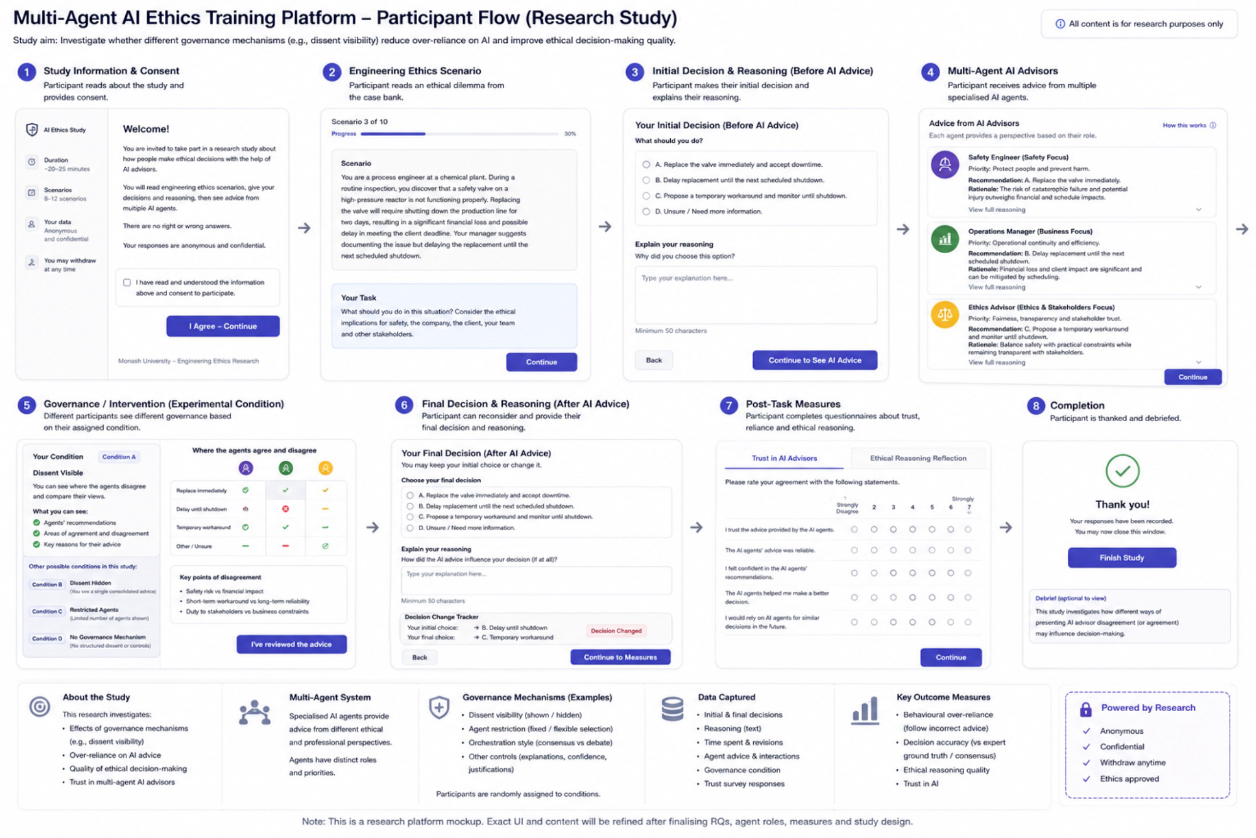
Flow: engineering ethics scenario → participant makes a decision → multi agent AI provides advice → participant can reconsider → final decision → collect measures

Ethics application : Design and Development of a multi-agent AI ethics-training platform.

Consider including in the background/lit survey/related work section.

- Over reliance definition - IfMath behind the calculation - need to know variables…. recursion what is your goal - <10% considering constraints
- Over-reliance = (number of cases where the student's final decision matches the AI's incorrect advice) ÷ (total number of cases where the AI's advice was incorrect)

Action items
- Lit surveys: Create an excel spreadsheet
- Start the template for W12 initial paper - 4 pages - Russel
- Ethics approval MUHREC - Russel
- Work on objectives - add more )
  - Added 1.2, 2.1.1, 4.0 and 5.0
- Identify requirements (FR and NFR) for our multi-agent AI ethics-training platform. (fixed set of Agents or flexible options)
- Mockups + Personas
- Prepare for the Week 8 interview presentation (Context, background, Aim, RQs, RM overview, prelim findings, PoC.., plan for S2 research - Gantt chart)
- CRAP: find similar for measuring AI agent reliability…
- Draft answer for three Ethics application questions?
- Log into the following: https://ethicsapps.monash.edu/ActivityForm/Index
- Module - Risk, OH&S Frevvo, ?? Sarah -> Week 5 - Russel to recheck the list.

In simple terms, explain the background and importance of this research
Do not include citations, explain all abbreviations and avoid using complex technical terms.
Refer to Readable's text scoring tool for tips to improve readability.

List the aims or hypotheses of the research pro

Give a brief overview of the research design
- Students - 18+ (exclude Malaysia and Indonesia citizens)
- Junior Working professional 18+ (<2 years of experience) - What types of decision - Technical and tactical
- IF Senior Working professional 18+ (5+ years of experience) - What types of decision - Business and strategic

18 Aug 2026 | FIT4701/2 Meeting - Agentic AI Plat…

18 Aug 2026 | FIT4701/2 Meeting - Agentic AI Platform
Attendees: ABM Russel Aryan Cyrus Ubaid Irfan

Apology: Ubaid

Notes
- 1st paper: Cognitive forcing function to reduce over reliance.
  - Three forcing functions (N=199)
- 2nd paper: Results were incorrect due to over reliance
  - When they went wrong
- Over reliance definition
- Measurement
  - Metrics what to measure
  - Opinion survey open to all
- Governance system x 3
- Go ahead with Narrative lit review (not systematic lit reviews)
- COSMIN type framework to evaluate - find alternatives for our project
COSMIN Taxonomy of Measurement Properties • COSMIN
- Six thinking hats as roles ?
- https://www.debonogroup.com/services/core-programs/six-thinking-hats/

- Aim:

"Investigate whether adding governance mechanisms to a multi-agent AI ethics-training platform reduce students' over-reliance on the AI and improve their ethical decision-making”

Central RQ: [to refine] Do we need governance mechanisms to a multi-agent AI ethics-training platform?

- Issues:
  - Unique roles to each agent
  - Poor decision making
  - Should we use utilitarian approach to agree with agent’s decision
  - How to validate the final decision?
  - What are the different roles required in a multi-agent AI ethics-training platform?

- R Objective 1: Investigate the consequences of a multi-agent AI ethics-training platform
- R Objective 2: How could we incorporate governance mechanisms in a multi-agent AI ethics-training platform?
- R Objective 3: Do governance mechanisms increase the quality of overall ethical decision?
- R Objective 5: Do governance mechanisms increase the reliability (using utilitarian or similar) of overall ethical decision?
- Any other objectives…

Sub RQs will be based on these objectives

Action items
- Lit surveys: Create an excel spreadsheet
- Start the template for W12 initial paper - 4 pages - Russel
- Ethics approval MUHREC - Russel
- Work on objectives - add more
- Excel summarise the studies (Abstract, method, findings , limitations etc)

04 Aug 2026 | FIT4701/2 Meeting - Agentic AI Plat…

4 Aug 2026 | FIT4701/2 Meeting - Agentic AI Platform
Attendees: ABM Russel Aryan Cyrus Ubaid Irfan

Requirements could be from lit OR surveys
Learning or self l

Meeting Notes:
https://onlineethics.virginia.edu/taxonomy/term/826

Russel ABM Russel to Everyone 6:57 PM
Agent4EDU
EduMAS

- Week 3 – Milestone 1: Launch (Moodle quiz)
- Week 5 – OH&S Risk Assessment (competency hurdle)
  - For the Clayton cohort, completing the online OHS and risk assessment training modules and associated tasks is mandatory for all students, including those undertaking computer‑based projects. Depending on the project type, students may also require further lab/building inductions and submission of RA on SARAH.
- Week 8 – Milestone 2: Confirmation (competency hurdle)
- Week 12 – Milestone 3: Initial Paper (competency hurdle)

Tab 11

